Even Semester (2019)



**BINUS UNIVERSITY**

**BINUS INTERNATIONAL**

**Student Information**

**First Name:** James **Last Name:** Barlian **Student ID:** 2101695176

Sherlyn Chance 2101693100

Nicander Chance 2101693113

**Course Name:** Computer Graphics  **Course Code:** COMP6505

**Major:** Computer Science **Lecture(s):** Raymond Kosala

**Title of Assignment:** Car Driving Simulator

**Type of Assignment:** Final Project **Due Date:** 1-7-2019

# Plagiarism/Cheating

Binus International seriously regards all forms of plagiarism, cheating and collusion as academic offenses which may result in severe penalties, including loss/drop of marks, course/class discontinuity and other possible penalties executed by the university. Please refer to the related course syllabus for further information.

# Declaration of Originality

By signing this assignment, I understand, accept and consent to Binus International terms and policy on plagiarism. Herewith I declare that the work contained in this assignment is my own work and has not been submitted for the use of assessment in another course or class, except where this has been notified and accepted in advance.

Signature of Student: (Name of Student)

1. James Barlian
2. Sherlyn Chance
3. Nicander Chance

# Table of Content

**Table of Content** **0**

**Introduction** **1**

**Models Used** **1**

**Implementation** **3**

Babylon.JS 3

Camera 3

Movement 3

Collision 4

**Gameplay** **6**

# 

# Introduction

In this report we will be discussing the project that we have created for our Computer Graphics class. Our group decided to create a simple 3D car driving simulator through a residential area. The purpose of this simulation is to drive according to the speed limit when going through a residential area. The game has 9 checkpoints that the player has to drive through in order to complete the game. The speed is set to a fixed rate and it cannot be changed. We used Babylon JS to create our driving simulator. Next we will discuss the implementation and how the simulator runs.

# Models Used

Shelby Ford Mustang

<https://clara.io/view/5bf7d3dc-a756-477a-bd40-1fab3583238f>

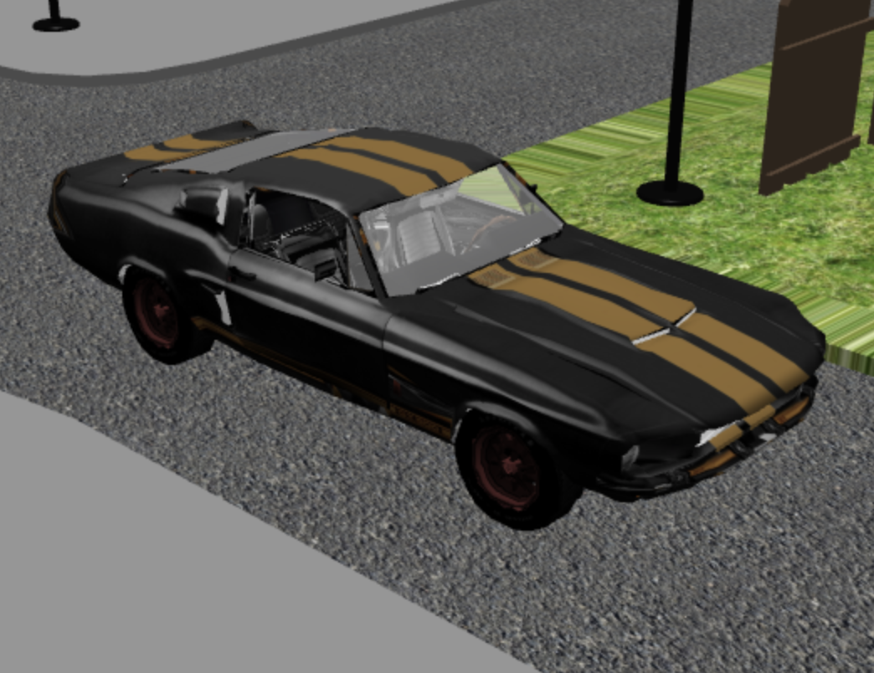

Map of the town

# 

# 

# 

Sky of the map

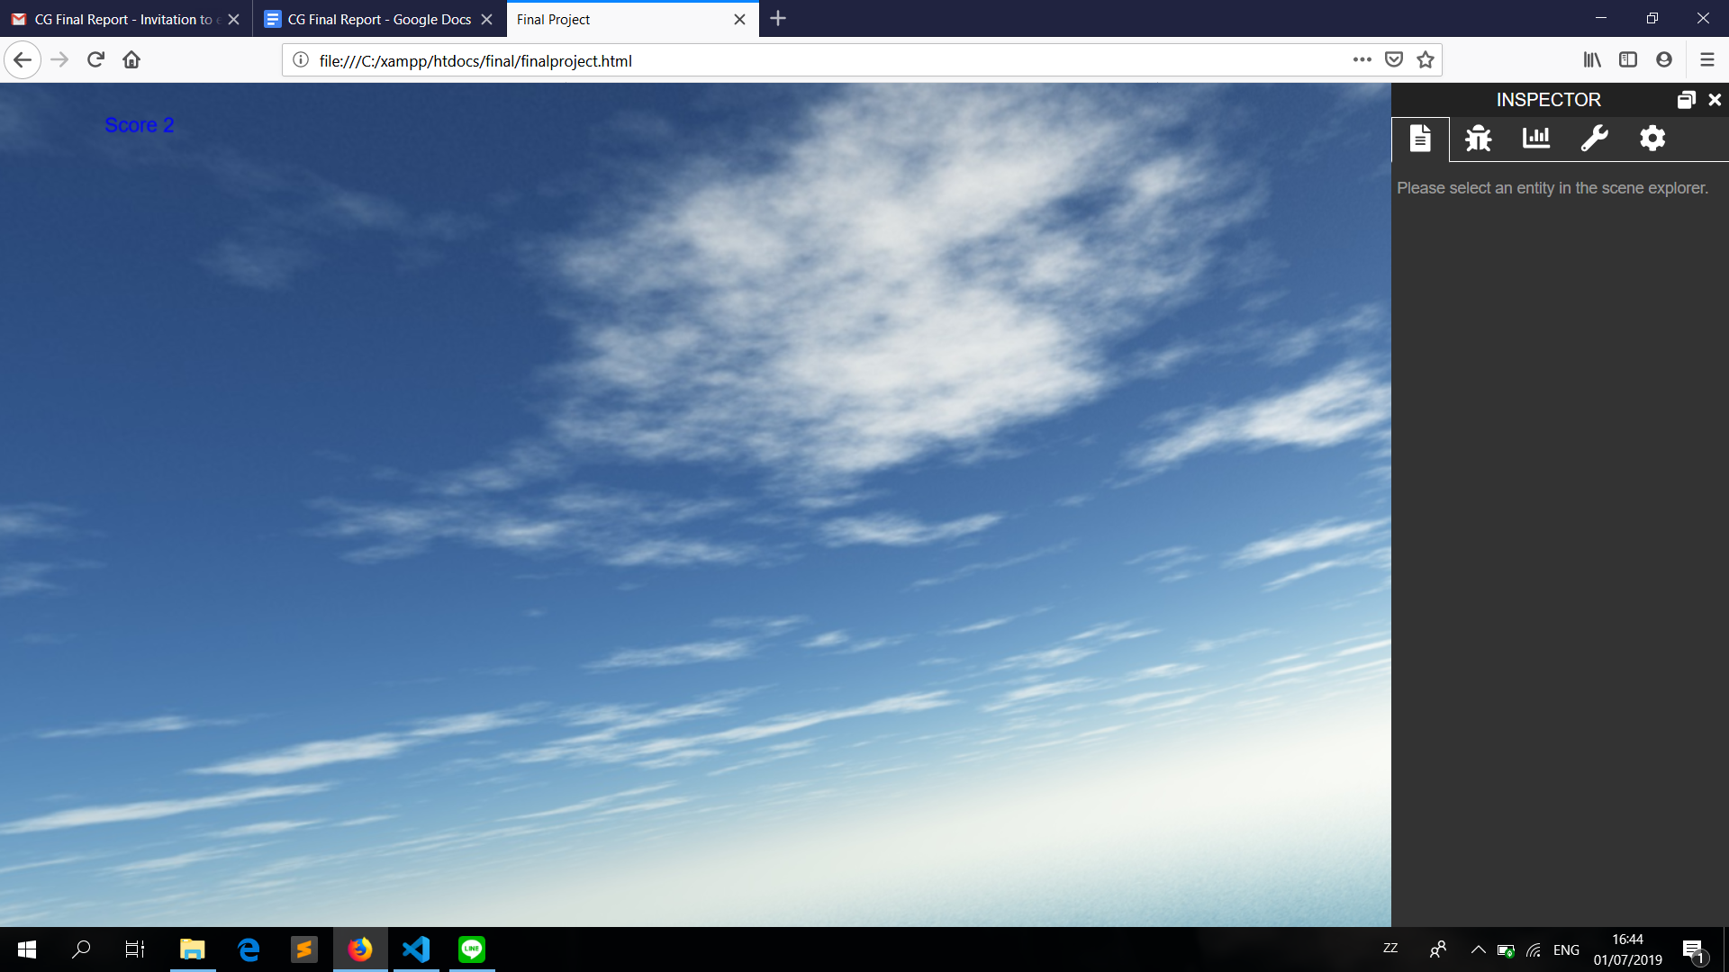

# Implementation

## Babylon.JS

Babylon.js is a real time 3D engine using a JavaScript library for displaying 3D graphics in a web browser. This is the language that we chose to use in order to make our project come to life. Our group used Microsoft Visual Studio and Sublime to edit the html file that we created for our simulator. We found models that were compatible to use for babylon on the internet and applied them to our simulator.

## Camera

We used FollowCamera which takes the Car as the target and follows it as it moves. We used this camera because this way, the player would be able to see where the car is heading easily.

## Movement

Uses the W, A, S, D keys.

W = Up

A = Left

S = Down

D = Right

We choose the WASD keys because those keys are the common keys usually used as movement. As for turning the car we base the turn on pivoting the car, so in this case the car will turn more realistically rather than turning straight on 90 degree angles. This is the formula that we used in order to turn the car realistically. When the car moves forward the distance is multiplied by the z axis, and as the car turns with “a” or “d” the car slowly turns by multiplying distance with the x axis, so therefore the car turns slowly to the direction that it is being directed. So instead of just changing the x or z rotation and axis immediately, we tried to move both axis at once so that it can rotate slowly diagonally.

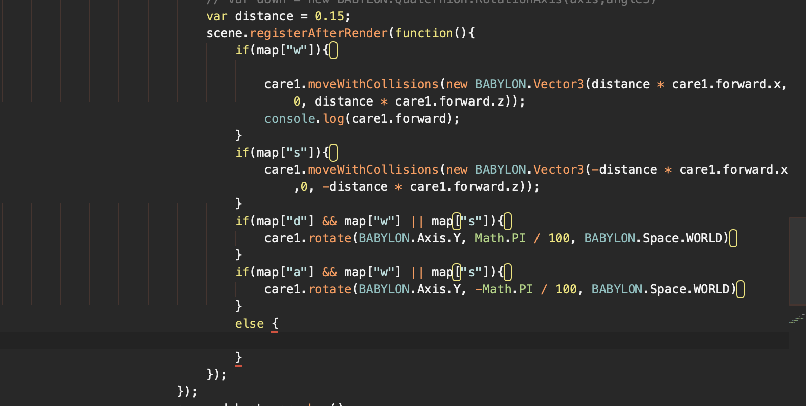

## Collision

Collisions of the objects in the object are collisions between the car and the buildings. Enabling collision between the car and the buildings use scene.enableCollision and the car.

# Gameplay

As soon as the game starts, the camera will pan to this view. Player will need to move the car to the nearest checkpoint and collect all the checkpoint in the map.

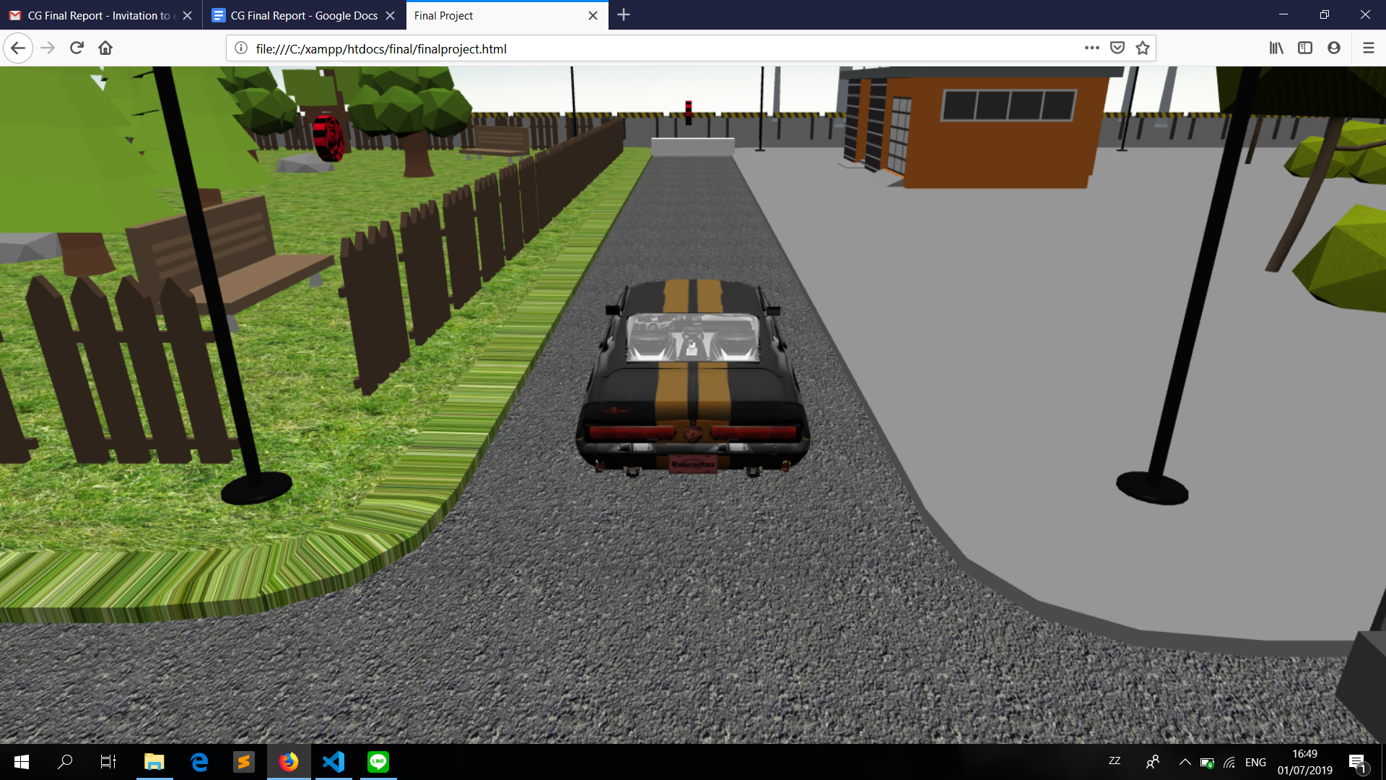

As you pass a checkpoint the score will be added by 1.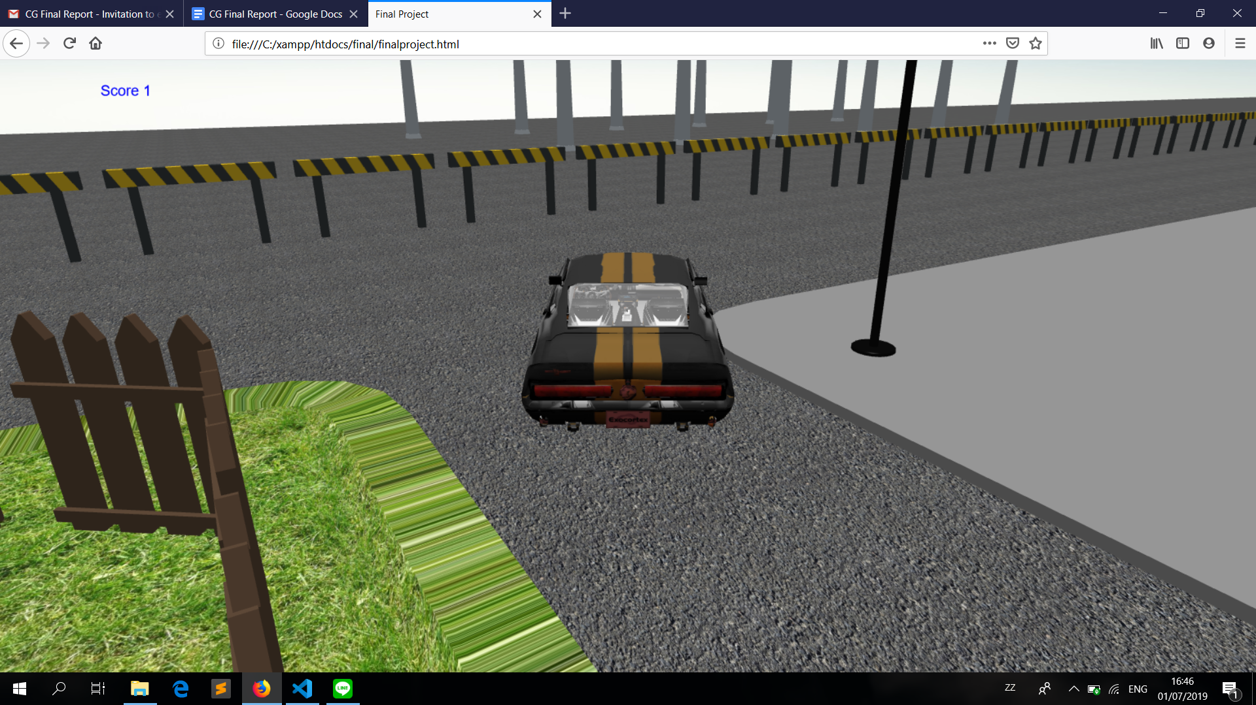

If you successfully passed all the checkpoint, an alert will be shown to inform the player that the player beat the game. The player can choose to continue driving around by clicking ok

